<page_start no = 1>
<sol_start id=1>
1. (3) Concave mirror
<sol_end>

<sol_start id=2>
2. u = –10 cm
m = –3
30 cm = v
(3) 30 cm, 7.5 cm
<sol_end>

<sol_start id=3>
3. (4) Both 2 and 3
<sol_end>

<sol_start id=4>
<sub_id = 1>
4. (i) Principal focus of spherical mirror - When light rays coming from infinity parallel to principal axis after reflection converge or appears to converge at a point behind the mirror is called principal focus.
<sub_id end>
<sub_id = 2>
(ii) Centre of curvature of spherical mirror – The centre of the sphere from which the spherical mirror was a part of is known as centre of curvature.
<sub_id end>
<sol_end>
<page_end>

<page_start no = 2>
<sol_start id=5>
<sub_id = 1>
5. Given (convex lens)
(i)
v = + 18 cm
= –90 cm
=
<sub_id end>
<sub_id = 2>
(ii) Nature : The lens is convex lens convex lens is convergent.
<sub_id end>
<sub_id = 3>
(iii) 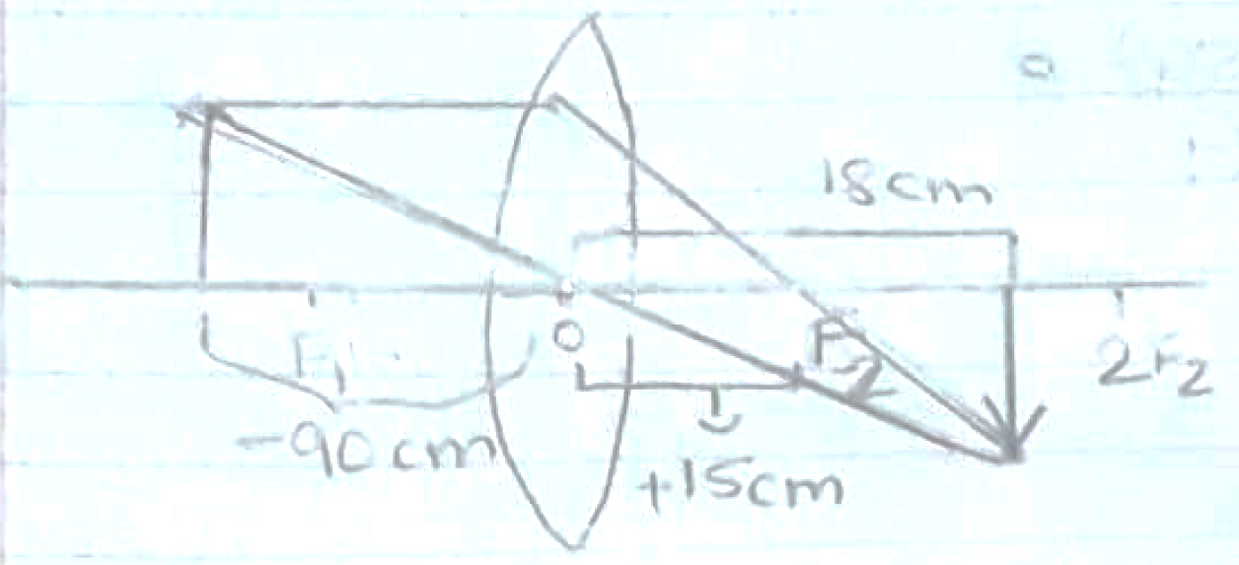
<sub_id end>
<sol_end>

<sol_start id=1>
<sub_id = 1>
6. (i) Given (concave mirror)
h_{o} = +7 cm
u = –27 cm
f = –18 cm
v = ?
h_{i} = ?
v = –54 cm
m = –2
–14 cm = h_{i}
Size : The image formed is 1 cm from the principal axis.
Nature : The image formed is real and inverted. The image formed is twice the size of the object.
<sub_id end>
<sub_id = 2>
(ii) Given (convex mirror)
2f = +5 m
u = 2 m
v = ?
2f = +5m
+2.22 m
Position : The image is formed +2.22 m behind the mirror.
Nature : The image formed is virtual and erect. The nature of the lens is diverging.
Size : The image formed is the size of the object.
<sub_id end>
<sub_id = 3>
(iii) (a) The nature of this mirror is real and inverted. The mirror is converging.
(b) Concave mirror is used so that dentist get an enlarged image of the tooth.
<sub_id end>
<sol_end>
<page_end>

